Date: 19 January 2020

To: Dr. Kathleen Campbell Garwood

From: Team 8 | Khanh Huynh, Christopher Stange,

Nidhi Vijayvargiya & Savannah Camp

Re: Analysis and Recommendations on Food Desserts.

A food dessert, as defined by the United States Department of Agriculture, is a piece of the country where it is difficult to obtain fresh fruits, vegetables, and other healthful whole foods at a reasonable price. Food desserts are thought to be brought on by numerous factors including transportation and income, with the nearest grocery store or market being far away. Many individuals living in food desserts turn to economical and readily available options such as fast food, which does not support wellbeing. To get a better understanding of food desserts and factors affecting well-being, we chose to evaluate how distance from fresh food correlates to poverty and how poverty relates to obesity.

To complete our analysis, we obtained reputable census information as well as average rates of diabetes and obesity. Specifically, we looked at the average poverty rate, comprised of the average of all census tracts, diabetes rate, and obesity rate organized by state. The distribution curve of the Average Poverty Level by state resembled a normal distribution (bell-curve), while that of Diabetes and Obesity are more bi-modal (see Appendix A). The average percentage of individuals with Diabetes is around ten percent, while the average percentage of individuals who are obese is around thirty percent. The population rate was obtained from the 2010 census, while diabetes and obesity rates were obtained from a 2016 poll. Although there is a gap in time, we were unable to obtain more updated census information, as one has not yet been conducted and reported.

As previously stated, our analysis focused on two areas:

1. Do those in rural areas experience higher poverty rates than those in

urban areas

**(2)** If higher poverty rate correlates to higher obesity.

Prior to completing our analysis, we predicted that:

1. Those living in rural areas are going to experience a higher poverty rate compared to those in urban areas, assuming that rural areas do not have the resources that those living in urban areas do.
2. States with a higher poverty rate are going to experience a higher obesity rate.

## **Overall Observations**

Through analysis, we determined that the highest average number of those living in poverty are geographically located in the South. See below for breakdown of smallest/largest average percentage of poverty.

The five states who experience the smallest average percentage of poverty are:

* New Hampshire (9.53%)
* Hawaii (10.75%)
* Maryland (10.99%)
* Alaska (11.23)
* New Jersey (11.51)

The five states who experience the largest average percentage of poverty are:

* Mississippi (24.69%)
* Louisiana (21.66%)
* Alabama (21.22%)
* New Mexico (20.79%)
* Georgia (20.52%)

## **(1) Poverty Rate compared to Location**

* Rural areas are generally located outside of towns or cities, many times thought of as the country or farm side. Because these areas are substantially far removed from the town center, we predicted that those living in rural areas would be more likely to experience poverty. This theory was disproven through the one-way Analysis of Average Poverty Percentage by location, as show in Figure 1. As the one-way ANOVA shows, Urban cities have a higher percentage average compared to the rural cities. There is a 95% confident that the average percentage of poverty for those living in Urban areas are between 3.1% and 3.5% higher than the average of those in Rural areas.

Figure : One-Way ANOVA

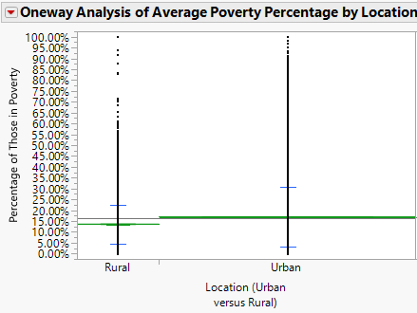

## **(2) Correlation of Poverty Rate and Obesity Rate**

For the correlation of Poverty Rate and Obesity rate, we hypothesized that poverty and obesity is related. Upon the initial review of the data, it appeared that our assumption was correct. Many states with high percentages of poverty also had high level of obesity. Our initial theory was quickly proven when we noted areas that have high rates of poverty and high obesity rates. Based on the Bivariate Fit of Poverty population by Obesity population (Figure 2), we see a strong correlation in the fit line.

Figure : Correlation Analysis

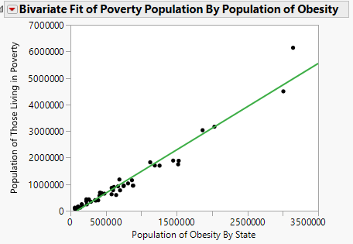

**Highlights of our analysis:**

* The minimum average percentage of poverty among the 50 States and The District of Columbia was 10%, while the maximum was 25%.
* The minimum average percentage of Obesity among the 50 States and The District of Columbia was 22.3%, while the maximum was 37.7%.
* There was only a 97.68% correlation between average poverty level of the population and average diabetes rate. This demonstrates an excellent relationship between poverty rate and obesity rate

See Appendix C for the details behind out highlight analysis. The correlation analysis seems reasonable due to individuals living in poverty turning to cheaper options such as fast food or pre-made, frozen foods. While these options may be budget friendly, unfortunately they do not support a healthy lifestyle.

**Recommendations**

Throughout our analysis we sought to examine certain factors that relate to general well-being. There is a high average percentage of poverty in Southern States as well as an excellent correlation between those living in Poverty and those who are obese. We would recommend conducting a study on a representative sample to compare why communities are experiencing a food desert against those that have support of healthy food options. By conducting a study comparing, we can then determine the best way to bring heathier and more cost-efficient options. Based on past studies of correlation between healthy eating and active lifestyle this promotes increased physical activity, which will reduce the obesity rate.

**Appendix A: Distribution of Average Poverty, Percentage of Diabetes, and Percentage of Obesity.**

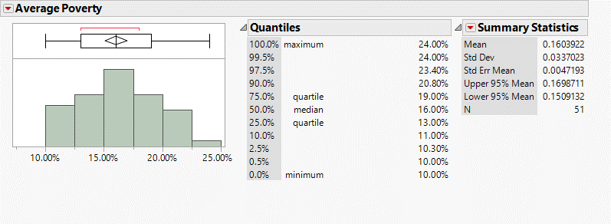

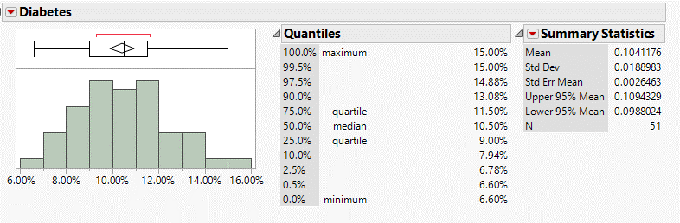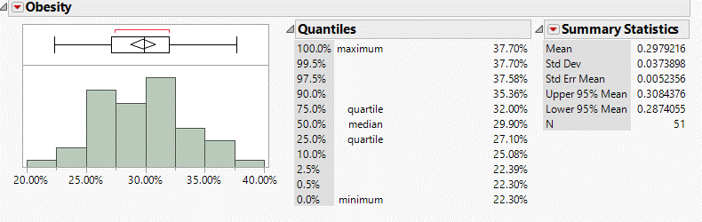

**Appendix B: Oneway Analysis of Average Poverty Percentage by location.**

**Appendix B: Analysis of Average Poverty Percentage by Location.**



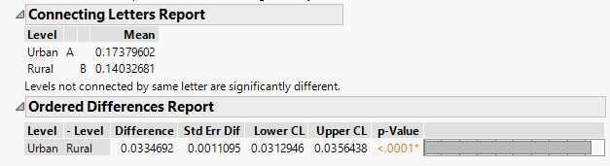

*The above chart compares percentage of those living in poverty to their location, either urban or rural. We wanted to determine if there is a difference between those living in Rural and Urban Areas. We noted a clear difference in the Connecting Letters Report, which shows a different value for both Urban and Rural locations.

**Appendix C: Fit of Poverty Population by Average Population of Obesity**



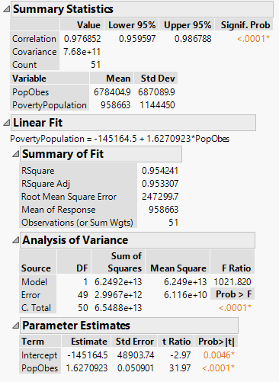

*The above chart compares the correlation of the average population of those living in poverty to the average population of obesity by state. We can observe from the visual that most of the points fall on the line, which represents a high correlation of points. Additionally, the Correlation Value of 97.6% demonstrates an excellent correlation.